Microsoft Fabric in a Day Lab Manual – **Lab 1**

# Working with Fabric Lakehouse – Creating your Lakehouse

## Introduction:

In this lab, you will create a Lakehouse in the Fabric workspace. A Lakehouse is essential because it serves as a centralized repository for all types of data, structured or unstructured. It enables efficient data management and analysis, forming the backbone of any data-driven operation. Go to home screen of your Fabric Workspace

## Logging into Fabric

**Create your Microsoft account if not exits.**

**Authenticate into Fabric:** Navigate to<https://app.fabric.microsoft.com/> and authenticate your account.

**Access the Fabric Workspace Home Screen**: This is your starting point for building the Lakehouse. The home screen is where you'll navigate through different aspects of your Fabric coursework.

## Creating Your Fabric Workspace:

**Creating your training Workspace:** Select **Workspaces** from the left-side navigation blade and choose **New Workspace**. Create a new Workspace using **fiad_<your_initials> (e.g. fiad_wtc)** as the naming pattern.

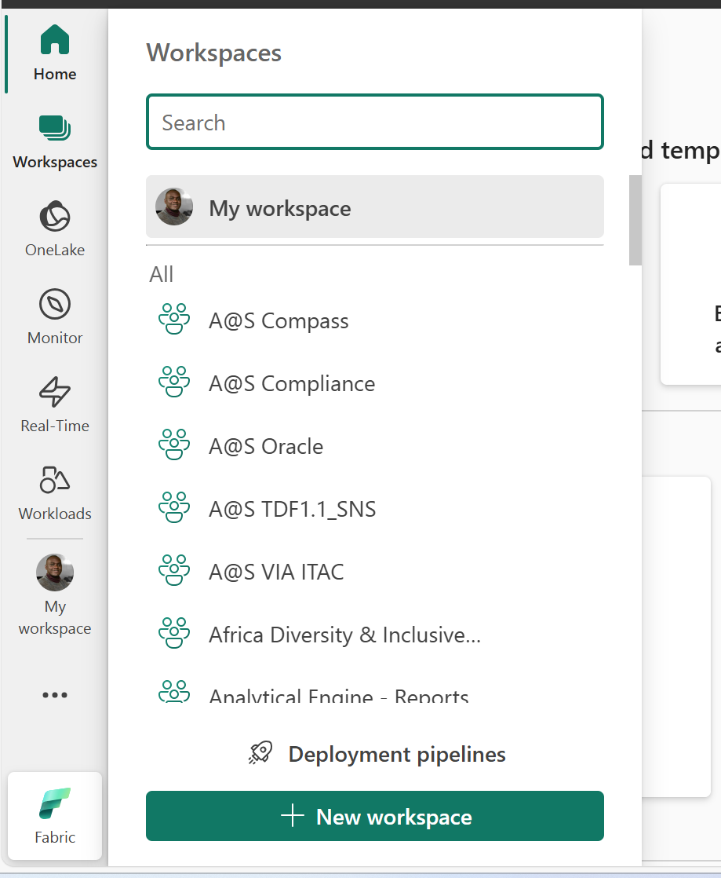

**Assign your Workspace to Fabric Capacity:** Expandthe **Advanced settings** in the **Create a workspace** blade. Select the **Fabric capacity** radial button and choose the available capacity from the dropdown then click **Apply**.

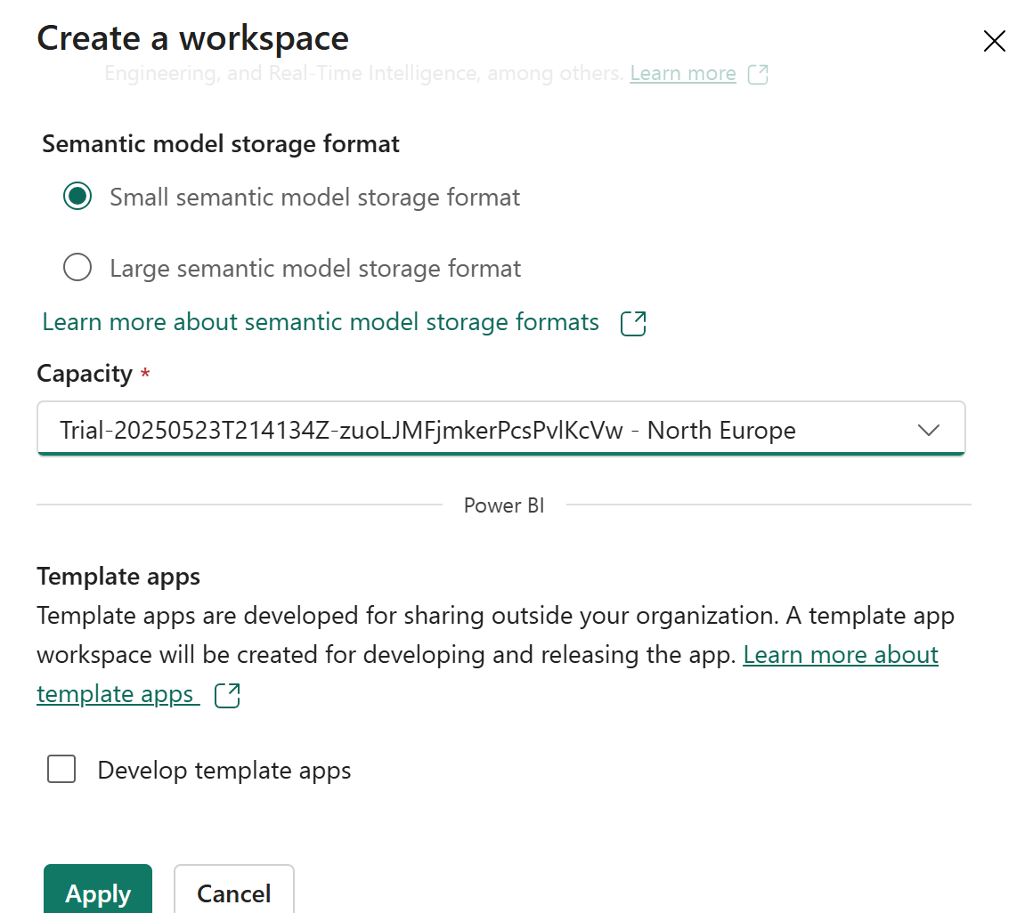

**Selecting the Correct Workspace**: Ensure that you’re working in the correct Fabric Workspace. From the left navigate pane, click the **Workspaces** button and select the workspace created in the previous step. **Do not use the “My Workspace” environment.**

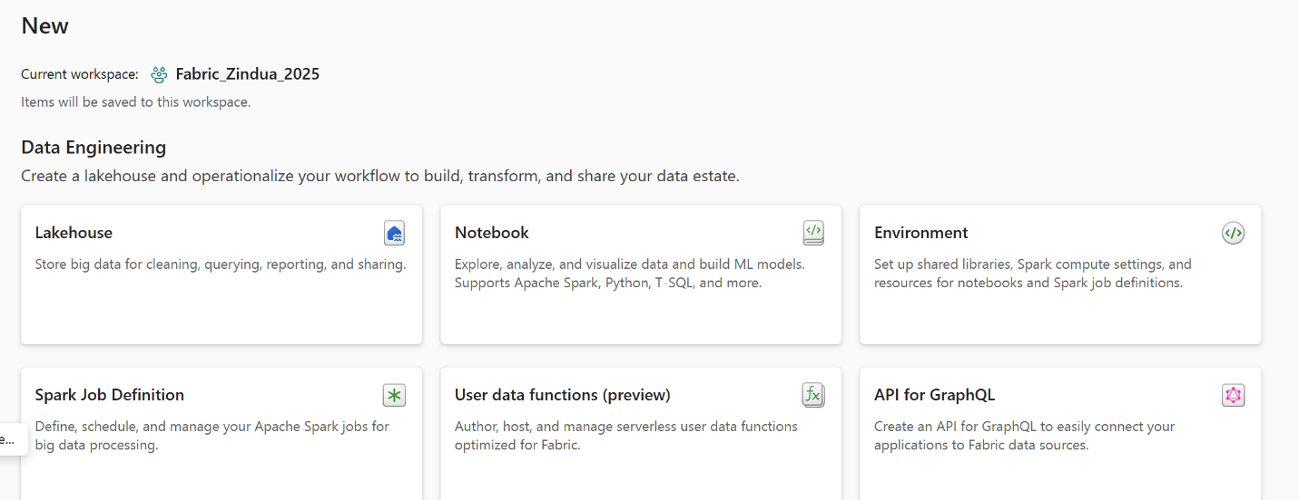

**Select Lakehouse:** By choosing **Lakehouse**, you initiate the process of setting up your data repository. This is an important step in establishing a central location for data storage and analysis.

**Name Your Lakehouse**: Personalize your workspace by naming your Lakehouse. Leave Lakehouse schemas disabled and click **Create**.

# Uploading a CSV File – Creating Your First Delta Table

## Introduction:

Now that our Lakehouse has been created, we will hydrate the lake with our first batch of data. To do so, we will be using Fabric’s Lakehouse ability of uploading a CSV file and converting it to a delta table in the lake.

## Load CSV and Create Delta Table:

**Load the sample file to Lakehouse File Container:** Navigate to your Lakehouse and right-click the **Files** section. Hover over **Upload** and select **Upload files**. Click the folder icon in the **Upload** **files** blade that opens on the right side of the window. Navigate to the location of the saved **package_types.csv** file from the course material, select the file, and click **Open**. Click **Upload** and wait for the file to be uploaded to the Lakehouse.

## Create a Delta Table:

**Load CSV to Lakehouse Delta Table:** Navigate back to the **Files** section of the Lakehouse explorer. Right-click the **package_types.csv** file, select **Load to Tables**, then **New Table**. Name the new table package_types, specify file has column headers, and it’s a “,” separated file, and click **Load**.

**Verify Table Creation:** Navigate back to the Table section of the Lakehouse and confirm the table was created. It may take a few minutes for the table to create as a spark session is being created to perform the operation.

**Note: It may take 60-90 seconds for the table to load due to background processes. Please be patient and do not try to create the table multiple times.**

**Note: If at any point you see “Undefined” instead of a table name in your Lakehouse please refresh your browser. The Fabric UI has not registered the Delta table being created yet and a refresh should resolve the issue.**

This lab is now complete.